LAB 4:
Task Description#1
● Zero-shot: Prompt AI to write a function that checks whether a given year is a leap
year.
Expected Output#1
● AI-generated function with no examples provided
Prompt: generate a python function that checks whether a given year is a leap year and ask user for input values and display it.
Using gitHub copilot:
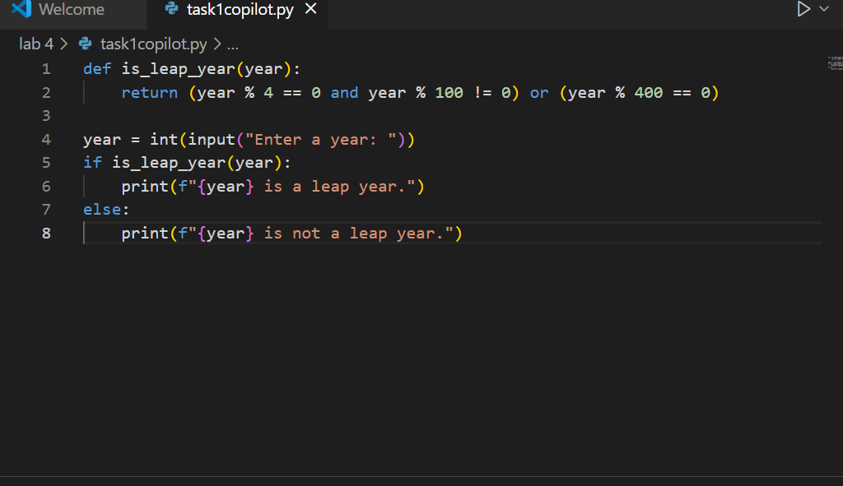
Output:
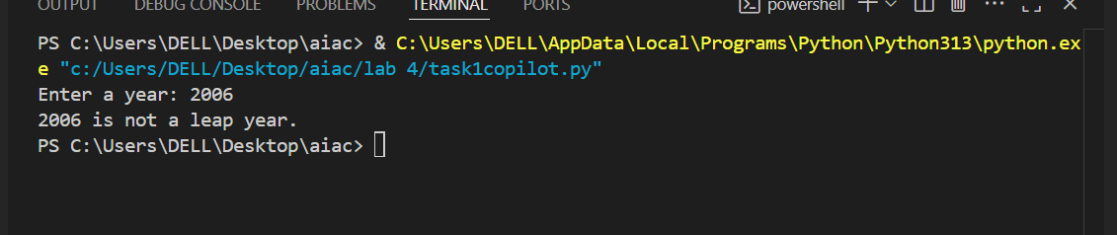
Using cursor AI:
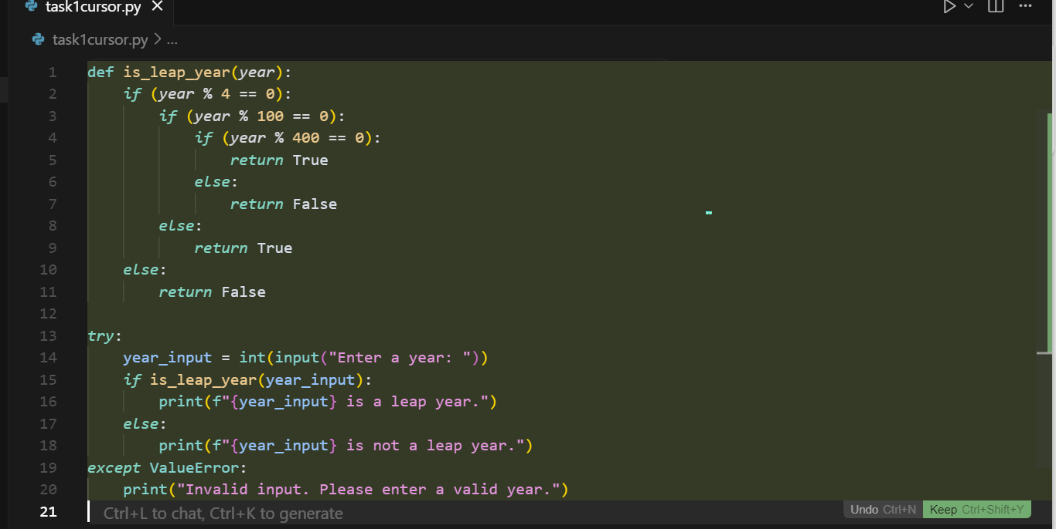
Output:
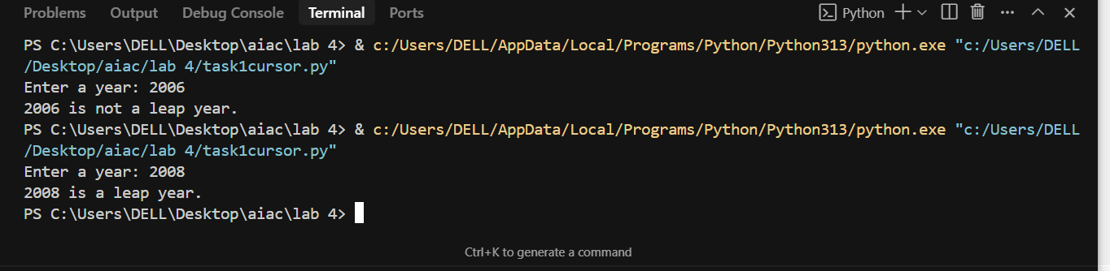
Task Description#2
● One-shot: Give one input-output example to guide AI in writing a function that converts centimeters to inches.
Expected Output#2
● Function with correct conversion logic
Prompt: generate a python function that converts centimeters to inches and ask the user for input values and display it. Example:10 centimeters converts to 3.93701 inches
Using GitHub copilot:
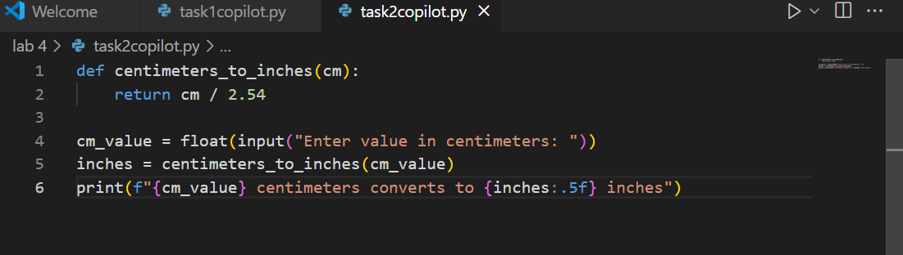
Output:
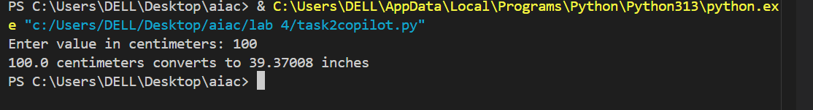
Using cursor AI:
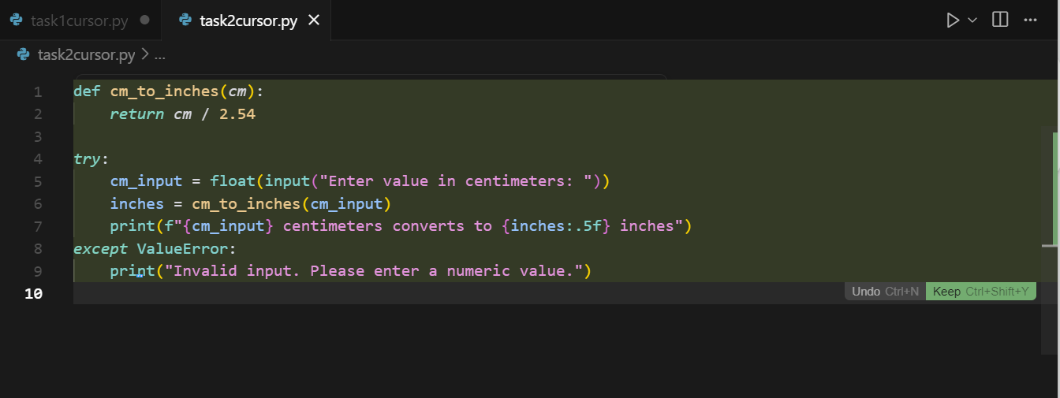
Output:
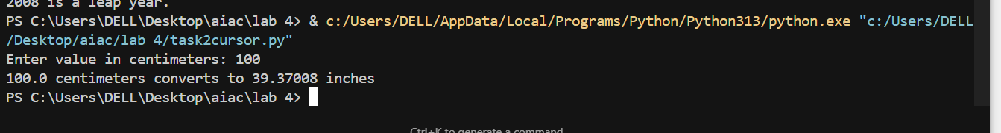
Task Description#3
● Few-shot: Provide 2–3 examples to generate a function that formats full names as“Last, First”.
Expected Output#3
● Well-structured function respecting the examples
Prompt: generate a python function that formats full names as “Last, First”.And ask user for input values.Example1:john smith to smith john.2:Donthi Varshitha to Varshitha Donthi.
Using GitHub copilot:
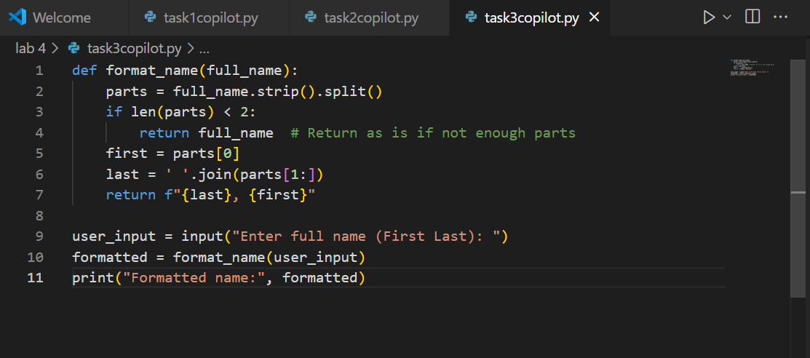
Output:
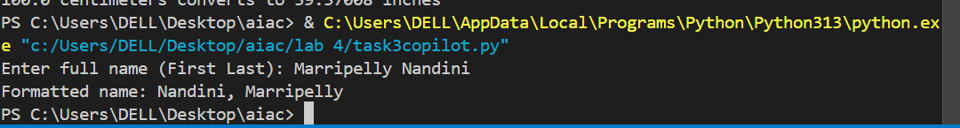
Using cursor AI:
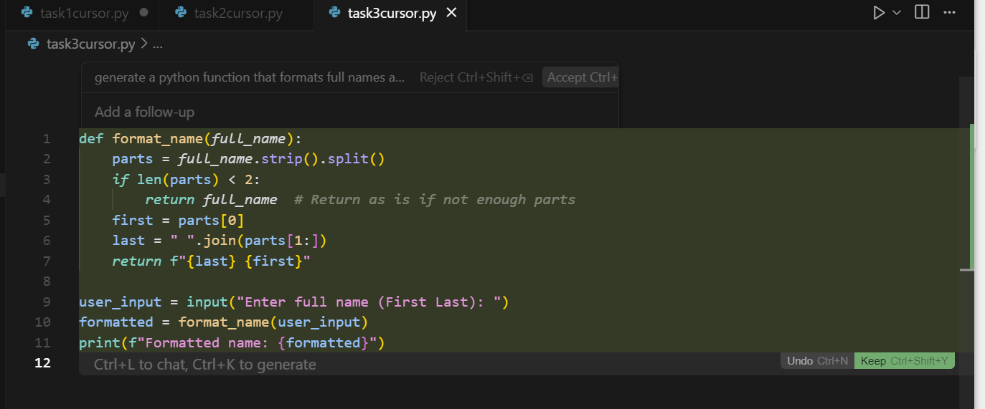
Output:
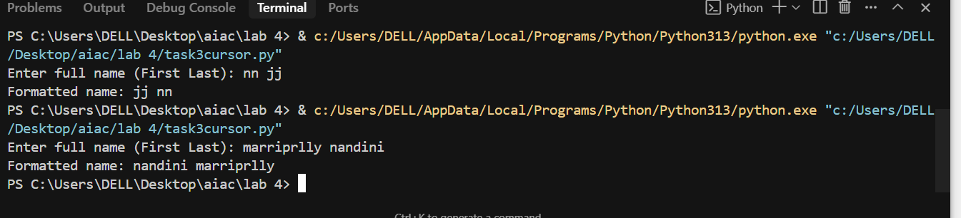
Task Description#4
● Compare zero-shot and few-shot prompts for writing a function that counts the
number of vowels in a string.
Expected Output#4
● Functional output and comparative reflection
Using gitHub copilot:
Prompt1: generate a python function that counts the number of vowels in a string and ask the input values from the consol and display it.
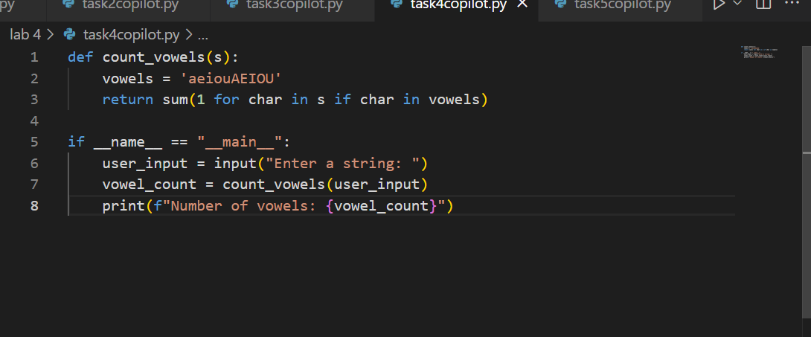
Output:
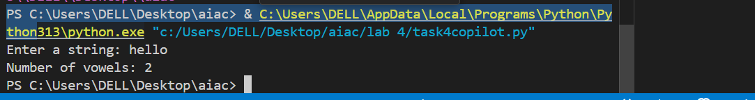

Prompt2: generate a python function that counts the number of vowels in a string and ask the input values from the consol and display it.Example:1.hello it has 2 vowels.2 python it has 1 vowel

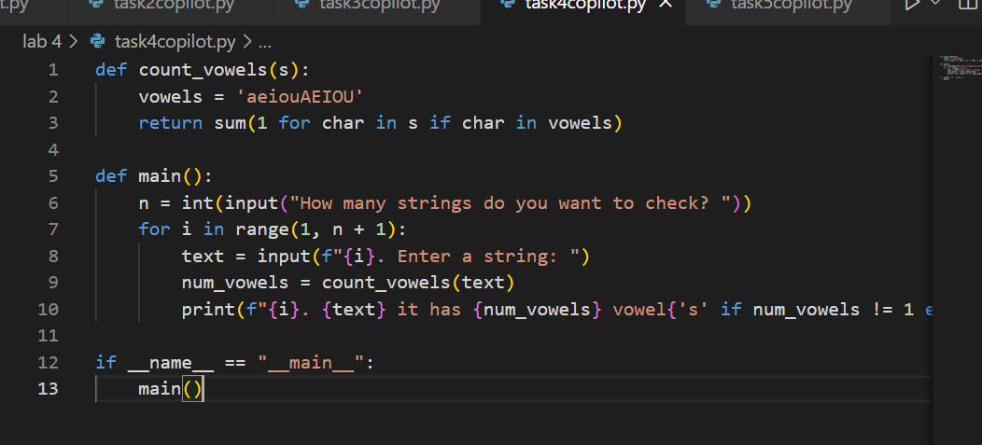
Output:
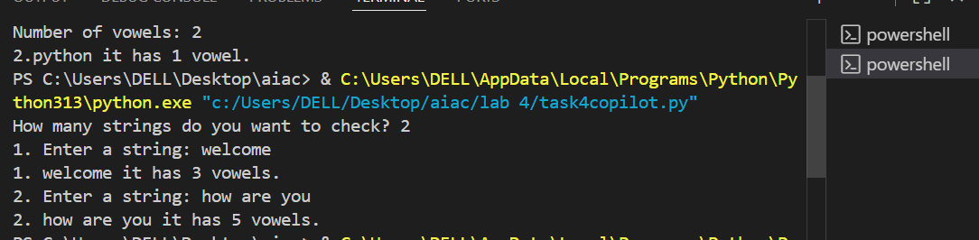
Using cursor AI:
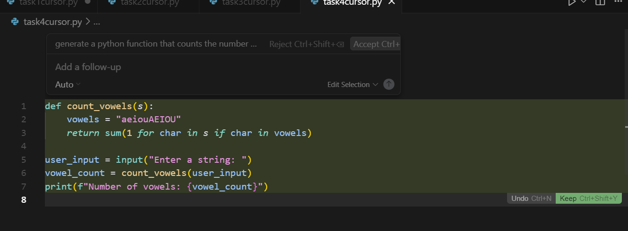
Output:
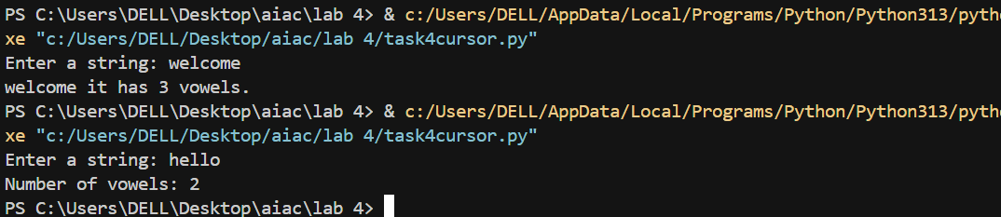

2.
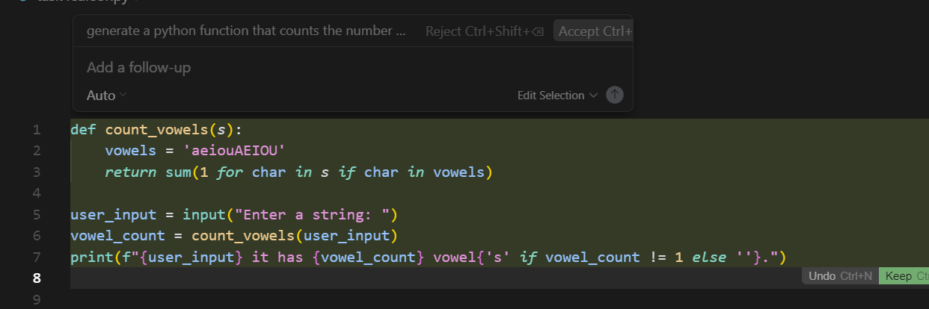
Output:
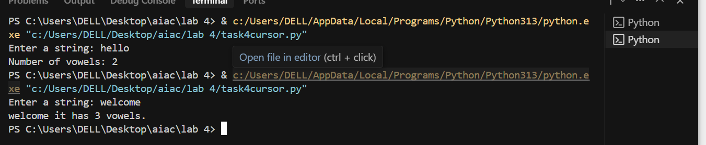

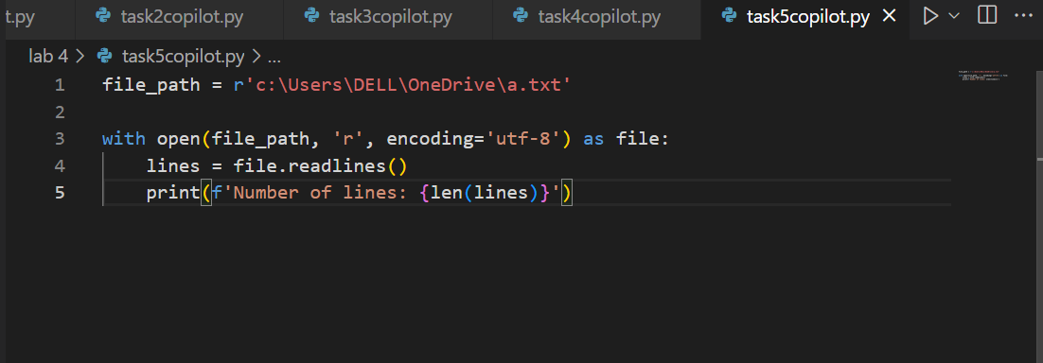
Output:
